TELUS PureFibre™ Drop notice for T’it’q’et residents
Why am I receiving this letter?
This letter is to inform you that TELUS will be placing a PureFibre Internet drop to your home during construction of the TELUS PureFibre™ network in your area. Construction is anticipated to take place in late March through early April 2024.
The drop process
The term “Drop” is the process of running the cable from an aerial utility pole or from an underground conduit to the utility box of the residence, which are typically grey in color. This does not mean a resident must purchase services. It is only a process that prepares TELUS to provide service in the future should that resident choose to subscribe. The process is all outside work and there is no inside disturbance to the home.
What does this process look like?
There are 3 main scenarios commonly seen in the field. Below you will find illustrations that best capture the process.
- Aerial Drop - Cable is run from an aerial utility pole to the home.
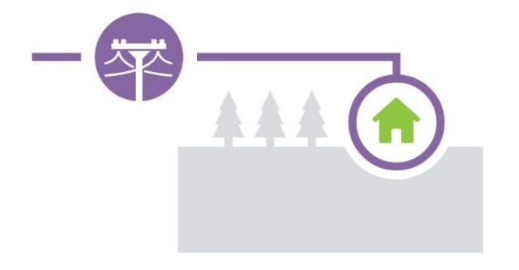
- Direct Buried Drop - Cable goes through underground conduit and surfaces at the utility box of the home.
- Combined Aerial/Direct Buried Drop - Cable can go to either a utility pole first or underground conduit first or second depending on the scenario required.

What is required from me?
- Ensure a clear pathway
  - If aerial, most objects can be avoided once the cable reaches clearance height, but tall objects might be identified as obstructions.
  - Underground, the path may need to be cleared and the drops team may identify this during prefielding.
- Create awareness - Be sure to alert your family or any other residents that this process will take place. This will ensure no one is surprised by activity outside the home and will allow for necessary safety precautions of residents.

You will receive another notification once the network is running and available for purchasing services such as PureFibre internet, OptikTV, and a variety of security packages.

Questions for your Administration  Janice Whitney  tfnadmin@titqet.org | Questions for TELUS  Elsie Kipp  elsie.kipp@telus.com

